Bellbrook Music Boosters
10Jan2022
7:15 pm
Zoom Meeting ID: #913 156 9591
Meeting Recorded in its Entirety
General Membership Meeting Minutes

Call to Order: 7:18 pm
Roll Call: Appendix A
Welcome:
Approval of the General Membership Meeting Minutes, 06Dec2021:
- Jen Volmer, 1st motion, Brett Woeste, 2nd, All Approved
Old Business:
- Poinsettia Sale
  - Chair of the sale, Heather Newell, reported on this year’s profits.
    - 2021 Booster Profit: $3177.70 (30% increase in sales from 2020)
    - 2021 Student Credit Distribution: $761.80.
  - Heather thanked all of the students/families for the great sales, as well as all of the volunteers who assisted at pick up.

- Winterguard Budget Update
  - The 2022 Winterguard budgets have been fully approved, as of Dec. 2021.
  - With the help of Trustee Chair Larissa Scott, Treasurer Kevin Hobbs, President Melanie Glover, and Guard Director Sheldon Apo, we are working to make sure all budget columns for the 2021 season zero out.
  - Strides have already been made with the assistance of Director Barb Siler.
  - We will continue to have an offline conversation in attempt to fully resolve this issue.

- Winter Invitational Update
  - Invitational Chair Danielle Woeste reported that the next planning meeting will be on 11Jan2022 at 6:30 pm via Zoom.
  - There are currently 39 groups registered for the event that will be held on 05Feb2022.
  - Further details shared by Director Andy Soloman:
    - MEPA will be requiring that everyone in the building be masked with the exception of performers in the warm up area and when they are performing. MEPA to “police” their mask policy.
    - Per Danielle, we will continue as planned for a “normal year” (pre-Covid) unless MEPA or the District make changes, impose new rulings.
    - Danielle will be putting out a call for volunteers for the Invitational soon.
New Business

- Treasurer’s Report-Appendix A
  - Financial Audit due
    - The yearly financial audit is due in January per the BMB By-Laws. However, with the advisement of the Audit Committee, the audit will be postponed due to safety concerns about meeting in person, in relation to the current Covid-19 surge.
    - The audit will be rescheduled at a later date when deemed safe to do so.

- Board of Trustees’ Report
  - Trustee Chair Larissa Scott not present. However, all of the Trustees will be having a meeting on 17Jan2022 to discuss topics such as parent involvement and communication.

- Officer’s Report
  - The four Officers in attendance have nothing to report at this time.

- Director’s Report-Appendix C
  - Update on Grand Nationals meeting held in Dec2021 between Mr. Soloman, Dr. Cozad, and Mr. Hann
    - Mr. Soloman reports that the District has stated that they will cover the full cost of bussing for Grand Nationals 2022.

- 8th Grade Night:
  - This event will be held in the BHS Band Room on 06Feb2022 at 6pm. The purpose of the event is primarily to discuss HS Music Program Curriculum choices for the incoming Freshmen class.
  - The Boosters, various fundraising events, and Band Trips (Disney World and NYC) will also be discussed.

- Future Planning for Marching Band Season 2022:
  - Homecoming will be held on 24Sept2022, which is earlier than usual.

- Administrator’s Report
  - Vice Principal Todd Whalen not present at this time. The Administration continues to offer their full organizational and logistical support to all of Bellbrook’s Music Programs.

- Fundraising

  - Dine Outs
    - Kristin Selvaraj shared the following upcoming events:
      - 24Jan2022: Dine Out with McIntosh’s from 4-10 pm, Dine in and carry out. The Boosters will receive 15% of the sales after a minimum of $300 is spent.
      - Feb2022: Nationwide Panda Express Dine Out
      - Mar2022: Chipotle Dine Out

- Spring Flower Sale
  - Chair Karen Beidelschies reports that the Spring Sale with new vendor, Foertmeyer & Sons, will be held 04Mar-18Mar2022 (in person sales), with the online sale ending 21Mar2022.

- Pie Peddler
  - The sale dates are unknown at this time, but Easter is later in April this year, and the pie sale/delivery will most likely coincide with that holiday.
- Open Forum
- Sponsorships:
  - Trustee Rod Silva reports that he is working with Nick Falzerano on the sponsorship vinyls.
  - Rod also plans to send out a second request for IPE shirt sponsors

- Winter Invitational Program Photos:
  - Danielle Woeste states that Nick Falzerano has inquired about an IPE photo for the Invitational Program.
  - Director Andy Soloman is unsure if the IPE uniforms will have arrived by that point or not. Danielle will assist Andy and Nick in coordinating a “matching photo”.

Adjourn: 7:07 pm
- Karen Beidelschies,1st motion, Tracey Waller, 2nd

APPENDIX A

Roll Call 10Jan2022:
- Melanie Glover
- Heather Newell
- Kevin Hobbs
- Rachele Alban
- Jon Selvaraj
- Karen Beildelchies
- Rod Silva
- Phoebe Dickman
- Danielle Woeste
- Andy Soloman
- Barb Siler
- Jen Volmer

  - Absent: Larissa Scott, Vice Principal Todd Whalen

- Kristin Selvaraj
- Sandy Baggott
- Amy Rodenroth
- Brett Woeste
- Laura Harr
- Eli Alban
- James Glover
- Tracey Waller
- Paula Kreitzer

APPENDIX B
Treasurer Report
10Jan2022
Page 1/6

Balances
Checking $50,057.14 (Includes 12K of NYC Deposits)
Savings $64,522.93

Booster Funds Overview:
Fiscal YTD Revenue: $ 40,843.83
Fiscal YTD Expenses: 36,080.69
Fiscal YTD Surplus/(Deficit): $ 4,763.14

Monies Received from Donations/Fundraisers
# | Source | Amount
1 | Scrip Distribution | $ 1,504.32
2
3
4
5

Treasurer Activities/Notes/To-Do’s
# | Status | Description
1 | ■ | 2021 990-EZ Tax Filing Drafted – Awaiting Online Service
2 | ✓ | Completed 1099-NEC Filing
3 | ■ | Reimbursement for 2020-2021 Winter Guard expenses (Sheldon)
4 | ■ | Document Future Needs (Uniforms, Replacement of worn-out assets)
5 | ■ | Draft of Treasurer’s Playbook
6 | ■ | Combined Federal Campaign: Application Process

Graphs: SEE BELOW

APPENDIX B
Treasurer Report
10Jan2022
Page 2/6

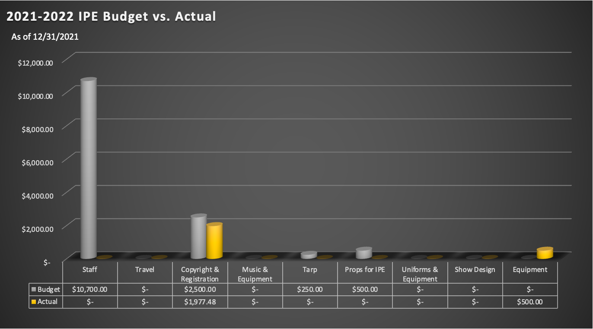
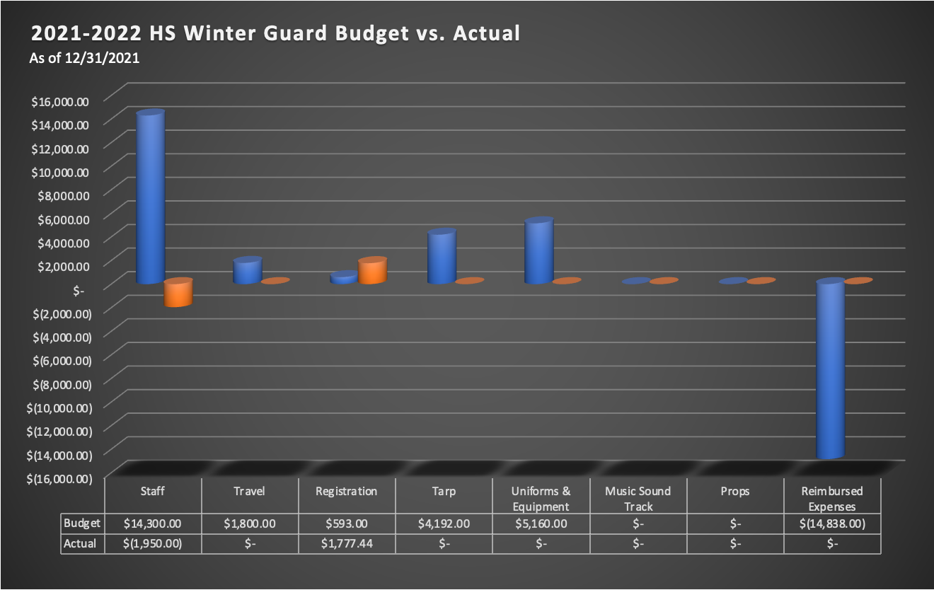
APPENDIX B
Treasurer Report
10Jan2022
Page 3/6

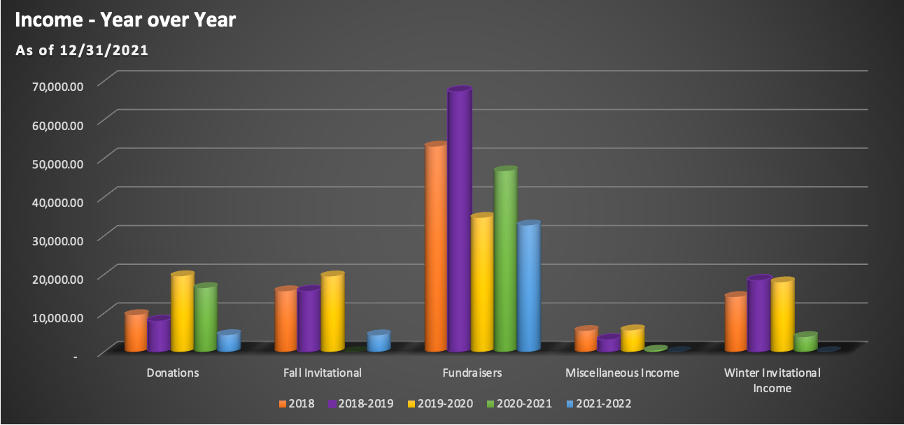

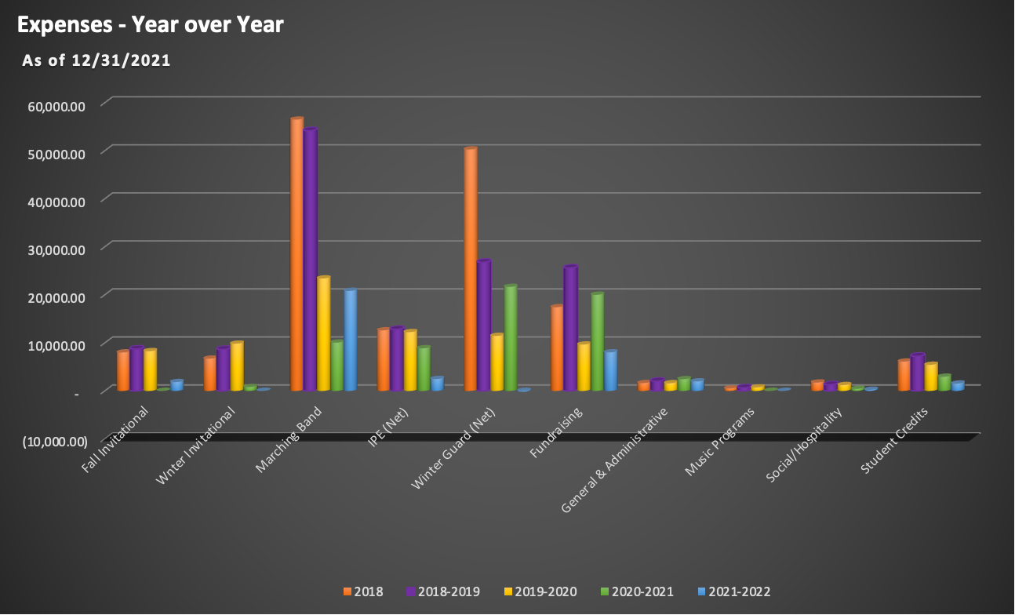

APPENDIX B
Treasurer Report
10Jan2022
Page 4/6

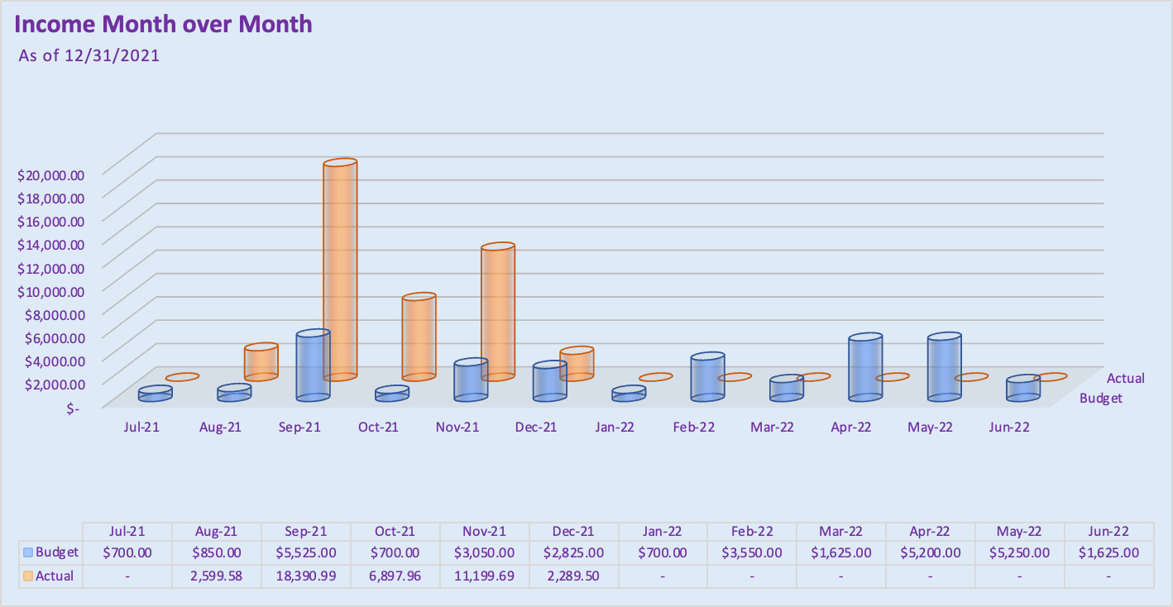

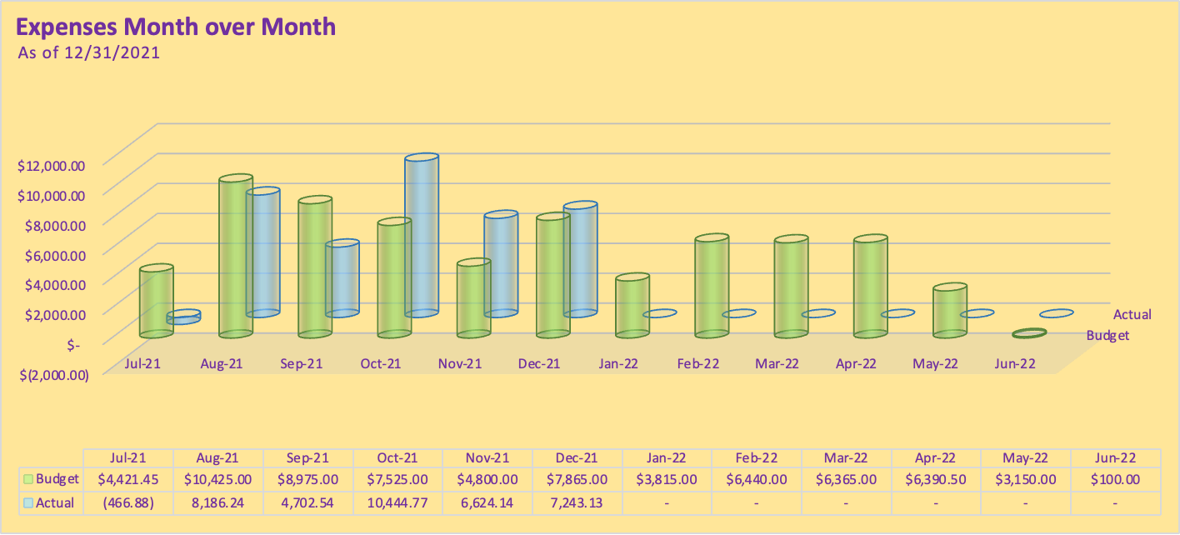

APPENDIX B
Treasurer Report
10Jan2022
Page 5/6

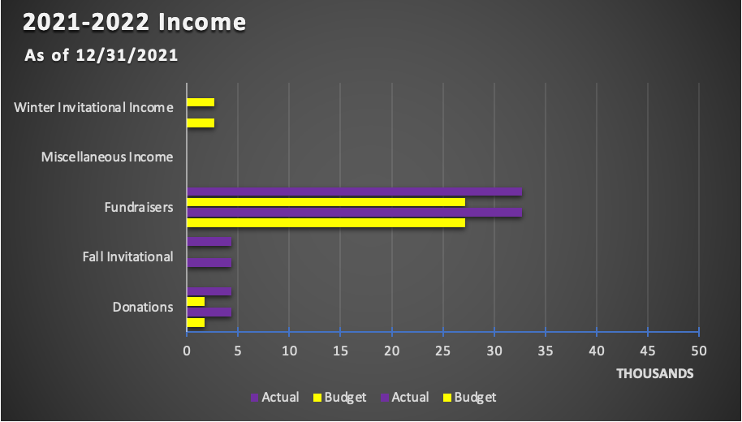

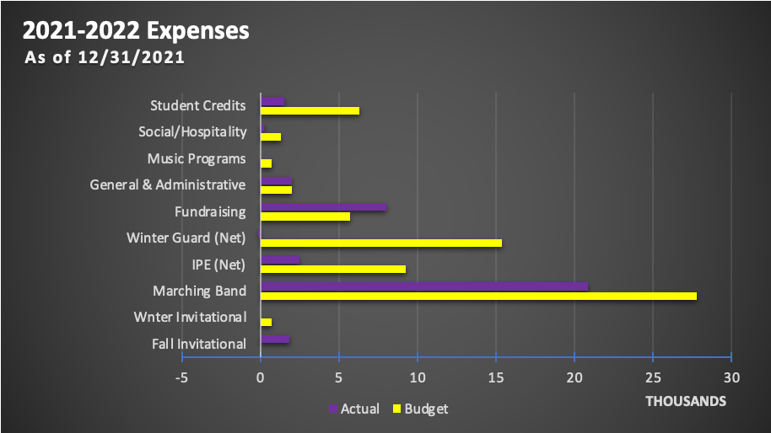

APPENDIX B
Treasurer Report
10Jan2022
Page 6/6

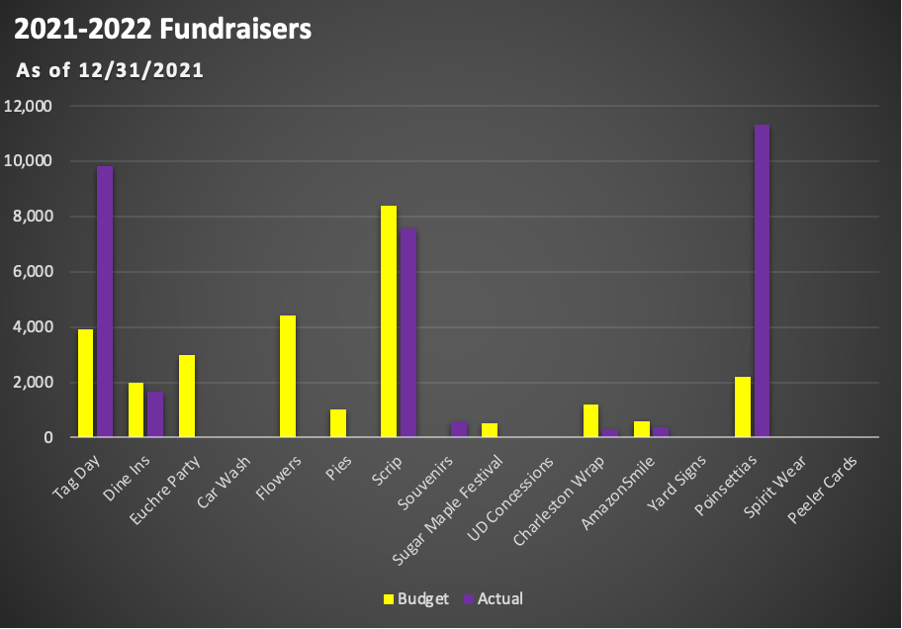

APPENDIX C
Director’s Report
10Jan2022

- Congratulations to all the concert bands on amazing December concert performances!
- Concerts coming up:
  - Saturday 1/22 - District Chamber Music Showcase! ***We have typically used this day as a way to reach out to families of middle school students and provide them with information about the boosters.! ***
  - Thursday 2/24 - Concert Band Festival
  - Saturday 3/5 - Music for All Concert Band Festival at Mason HS (times TBD)
- New York trip is being planned! $100 deposits as well as the first three $200 payments have already been paid.
- Jazz Band and Pep Band have started! Both groups are making great progress! Jazz band will have a guest clinician tomorrow, Mr. Wayne Markworth, who is going to talk to us about improvisation!
- Congratulations to Karin Peterson, Zane Pittman, and Matthew Jenkins for being selected to the Wright State Honor Band, taking place over President’s Day weekend!
- Next booster meeting will be preceded by our annual 8th grade parent night at 6pm. Students and parents are invited to attend to hear about music course offerings at the high school. Usually selected parents also speak, and 8th grade families are invited to the booster meeting at 7:15. Refreshments have often been provided…...?
- Tentative Disney Dates: 12/28/2022-1/2/2023 (look for a meeting in February, TBD)
- Marching band - Grand Nationals Bus Update
- Winter Programs
  - MEPA Bellbrook Invitational - Saturday, February 5
    - 39 groups are currently registered
    - Look for opportunities to volunteer/help with this event
    - Event mask policy: MEPA will be requiring masks for performers, staff, volunteers, and spectators at ALL events this season (announced at our director’s meeting Saturday). Performers are allowed to remove masks during warm up and/or performance at their discretion. I have forwarded this information to our district leadership so that they are aware.
  - IPE and Winterguard - seasons are underway and we’re looking forward to a great winter!

